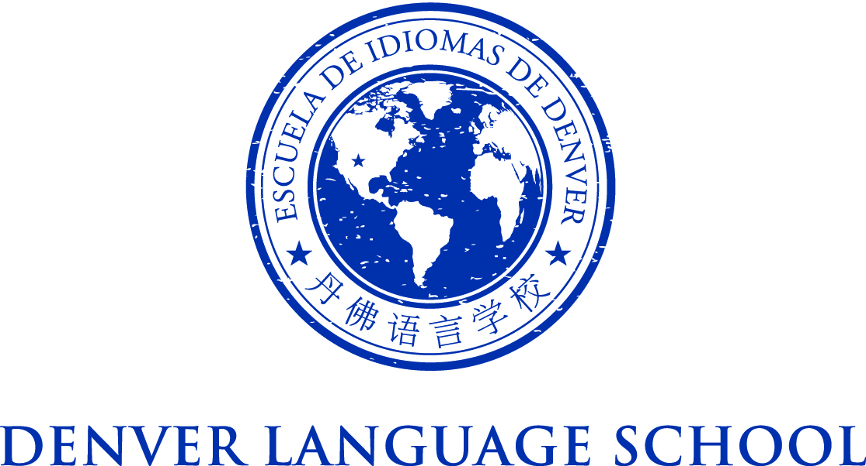

MEETING OF THE DENVER LANGUAGE SCHOOL BOARD OF DIRECTORS
Tuesday, May 3, 2016
Location: 333 Bellaire St. Denver, CO 80220
5:00 - 9:00 PM
Mission Statement – Achieve academic excellence and intercultural
competence through language immersion education
Agenda:

Board Training Meeting with the Colorado League of Charter Schools
Basics of Board Governance
o Legal Responsibilities of Charter School Boards
o Basic Board Roles and Responsibilities
§ Board/Administrator Relationship
§ Conflicts of Interest
§ Board Norms / Board Agreement
o Policy Development
o Running Effective Meetings

