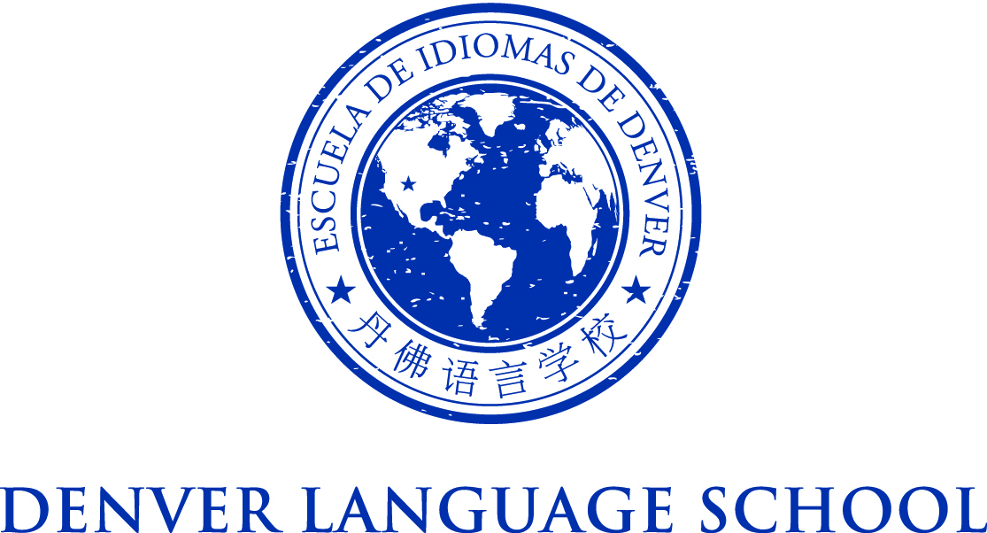

MEETING OF THE DENVER LANGUAGE SCHOOL BOARD OF DIRECTORS
Friday, September 25, 2015
Conference Call: 1-303-557-5869 PIN 1234
Time: 8:00AM – 8:15 AM

Mission Statement – Achieve academic excellence and intercultural
competence through language immersion education
Agenda:

8:00 AM - Call to Order

The purpose of this call is to vote on acceptance of the revised Leadership Structure to include an Assistant Principal at DLS West Campus

8:15 AM - Adjourn

