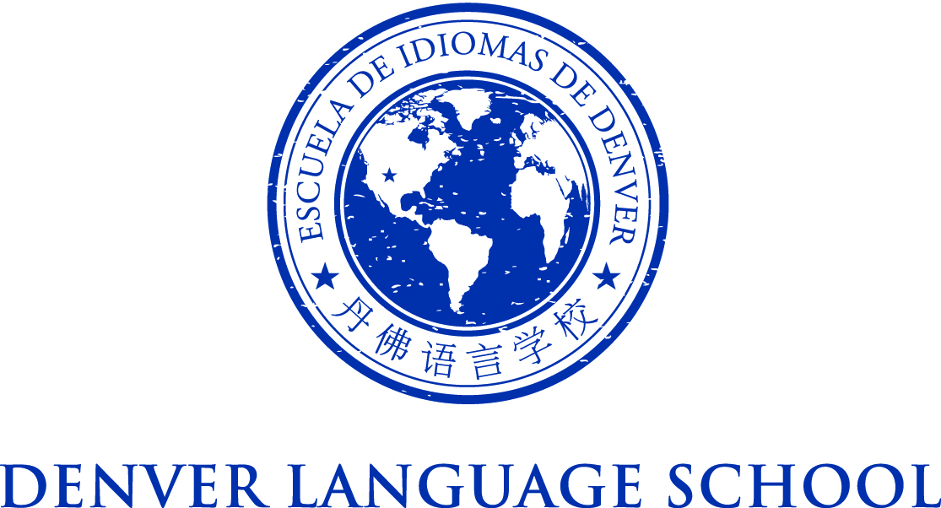

MEETING OF THE DENVER LANGUAGE SCHOOL BOARD OF DIRECTORS
Monday, April 25, 2016
Location: DLS East
Time: 5:00 PM
Conference Call (303) 557-5869 Pin 1234

Mission Statement – Achieve academic excellence and intercultural
competence through language immersion education
Agenda:

4:45 PM - Call to Order

Procedural Vote:
- Approve Minutes 4.19.16

Adjourn

