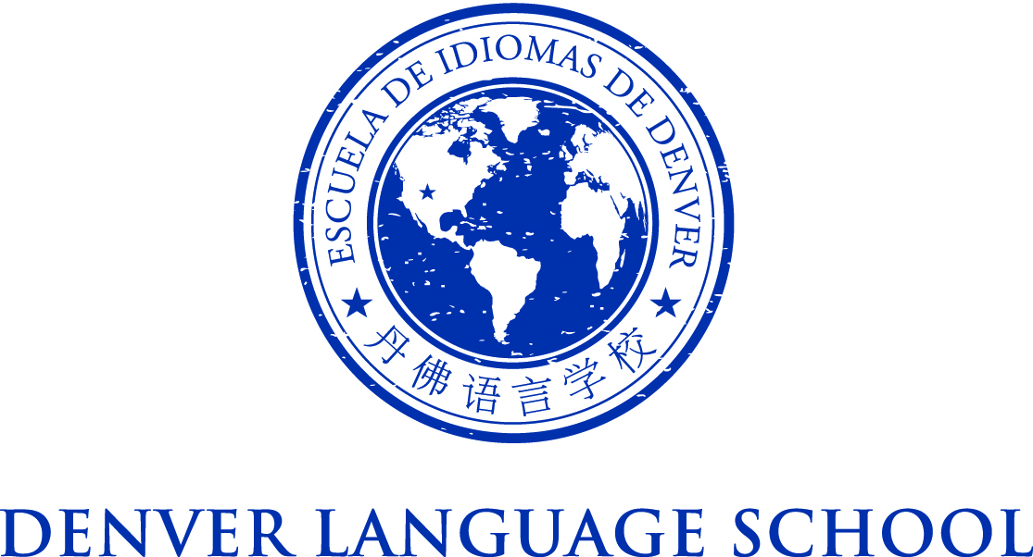

MEETING OF THE DENVER LANGUAGE SCHOOL BOARD OF DIRECTORS
Friday, April 29, 2016
Location: 2362 Spruce Way, Denver 80238
Time: 9am

Mission Statement – Achieve academic excellence and intercultural
competence through language immersion education
Agenda:

Time: 9am

PTA/Board/Parent Community Coffee

Adjourn

